

**————————————————————**

*Methods in spatial analysis*

**————————————————————**

Lecturer： Scholz, Johannes

Stu-Name： Chen, Yuzhou

Stu-number： s1104123

Major： Applied Geoinformatics

Winter semester, 2023

# Introduction

Visibility analysis is a spatial analytical technique that contains the process of evaluating the visible and non-visible areas from a specified observation point, including methods like viewshed analysis and line-of-sight analysis. It takes terrain, land cover, and elevation data into account, thereby providing a quantitative assessment of the visual accessibility and coverage of a particular geographic location.

# Base Data

All the datasets are as follows:

1. **Base DEM,** digital terrain model of Salzburg, with 5m spatial resolution, generated from airborne laser scan data.
2. **Range of Salzburg (AOI),** in the type of polygon, indicating the boundary of Salzburg.
3. **Salzburg DEM,** in the type of polygon feature, covering the whole Salzburg city and a certain range of its surrounding area, which help to better depict the viewshed.
4. **Castles,** in the type of point feature, covering all the castles within Salzburg city.
5. **Building Footprints,** in the type of polygon feature, representing all the outer edges covered by buildings’ structure at ground level.
6. **Viewpoint(s),** in the type of point feature, indicating the place where people observe the cityscape.

# Task 1: Describe the Use Case and Research Questions

## Scenario

With the expansion of urban areas and the increase in building density, people’s vision in the city has gradually narrowed due to the obstruction of numerous structures. This phenomenon prompts individuals to seek new viewpoints in the city or its surroundings to capture better natural landscape or cityscape.

The Gaisberg is a popular local mountain a few kilometers from Salzburg’s old town. With an outstanding elevation of 1287 m, it is a suitable place for hiking and viewing a large part of the Salzburg’s beautiful cityscape. In holidays, people often paraglide over the mountaintop, hoping to get a better view of the landscape while feeling the joy of flying.

At the top of the Gaisberg, there is a well-known viewpoint where an awesome view of Salzburg city can be captured (Fig 1). However, due to the obstruction of terrain and limitations in the observer’s line of sight, the visibility range is limited.

So, let’s start with a hypothetical scenario: To get a better view of Salzburg city, visitors suggest the construction of an elevated viewing platform here. The department try to propose viewshed analysis in GIS to obtain indicative quantification in optimizing the view of the cityscape from the newly constructed viewing platform. Considering the limitation of people’s vision, we will limit the viewshed radius within a distance of 7 km. And at the same time, the department need to assess the visibility of cityscape like numerous castles in Salzburg, for people who are paragliding over the Gaisberg.

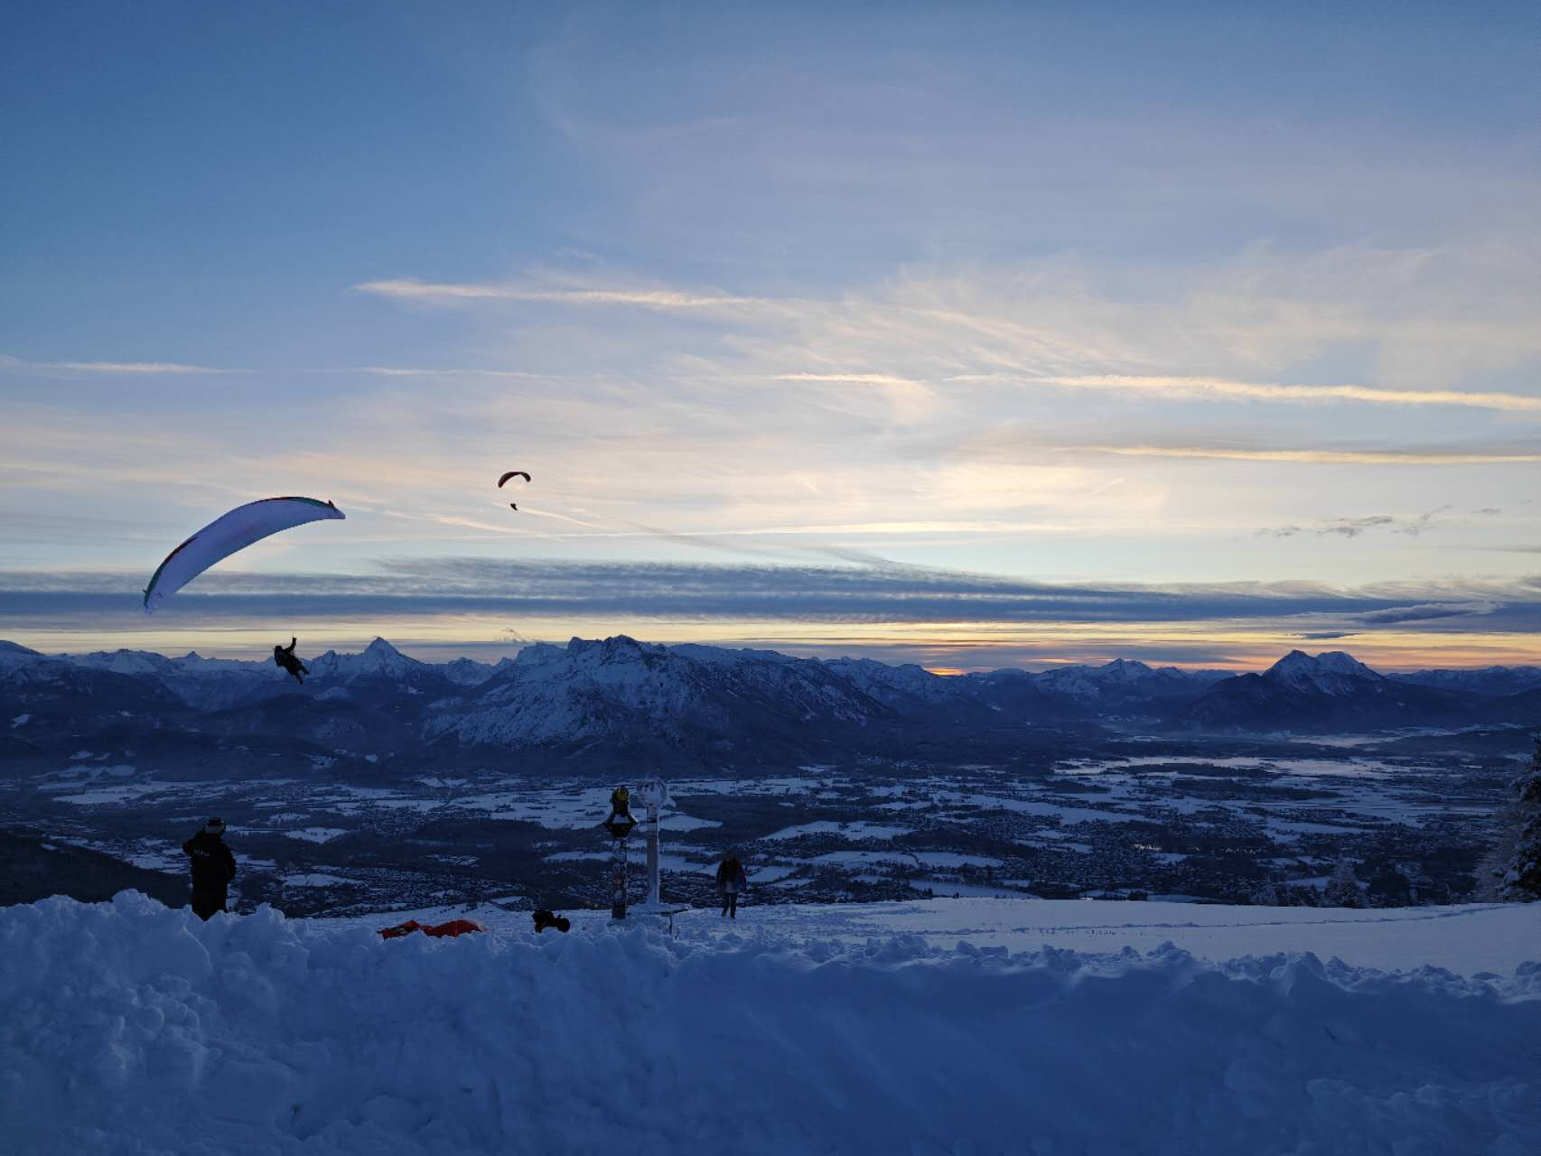

*Shot on Gaisberg

The task of this assignment is to apply some techniques in visibility analysis to analyze the sight and visible cityscape for tourists on the Gaisberg, including those who are paragliding.

## Research Questions

Considering that buildings are core elements of the urban landscape, we collected building distribution data in Salzburg city. To simplify the problem, we use a 2D building footprint instead of a 3D building model as the unit of area calculation. At the same time, we collected castle location point data to support the line-of-sight analysis.

The research will be conducted based on the existing data (Fig 2). In our scenario, several questions shall be answered in this study:



* Will some specific castles in Salzburg be visible to paragliders?
* How do you evaluate the negative role of the local mountains for paragliders viewing the castle?
* What areas fall into the topographic viewshed?
* What percentage of the buildings in Salzburg will be included in the viewshed?
* How does the visual building coverage ratio mentioned above change with the height of the viewing platform?

# Task 2: Line-of-sight Analysis for Castle View

## Analysis

This task aims to explore a line-of-sight analysis from the proposed location of a paraglider to all the castles in the Salzburg city, thus figuring out which castles can be seen and which cannot be. Considering that the line-of-sight is based on the terrain morphology, so elevation profiles are established to verify the line-of-sight result. In order to find eligible result, *Linear Line of Sight* and *Profile Graph* tools should be used.

## Hypothesis

Actually, the spatial location of paragliders will have a small difference with that of a tourist standing on the mountain. I assume the Paraglider’s height above surface is 8m, because the paraglider is hovering over the slope, not attached to it. The target castles’ height is set to 10m.

## Methods & Results

1. Use *Linear Line of Sight* to do line-of-sight analysis, with *Paraglider* as the Observers, *salzburgCastle* as the Targets, *salzburgDEM* as the Input Elevation Surface. In Visibility Options, Observer Height is 10m and Target Height is 8m.
2. There are several outputs after running this tool. What we need is the result named *castle_lineSight* shows the visibility along the line, and the one named *castle_targetVis* indicates the visibility of the target castle as follows:



It is obvious that there are totally 5 castles which cannot be seen by the paraglider. By using *Select by attribute* tool and viewing the table of *castle_targetVis*, these castles can be identified, which named Schlössl Überacker, Paschingerschlössl, Schloss Mirabell, Sekundogenitur and Primogentur, respectively.

1. Comparison of the visibility among the castles revealed that the castles located on the backside of the hill in the urban area did not have the same visibility, with some castles obscured and others visible. So, I selected **some sightlines** with the *Interpolate Shape* and *Profile Graph* tool to create elevation profile to verify the previous result, where *Interpolate Shape* is used to add z-factor to the selected lines, and *Profile Graph* is used to visualize the terrain changes along the line.

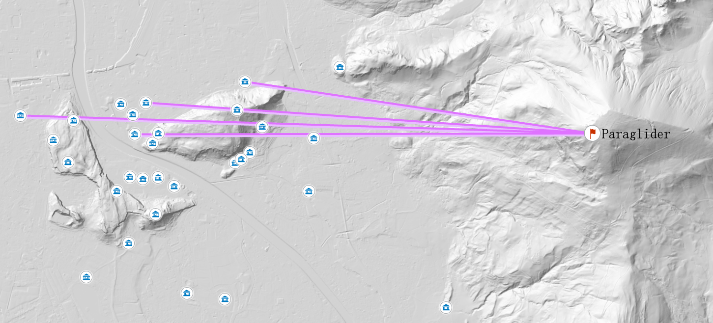

|  |  |
| --- | --- |
| Line-of-sight visibility result: visible (√) | |
|  |  |
| Line-of-sight visibility result: invisible (√) | |
|  |  |

1. **Try to analyze the result.** Firstly, the results of the line-of-sight analysis show that most of the castles within Salzburg can be seen by the paraglider. If we look into the distribution of visibility along the line of sight, almost all of the first third of the sightline is red, which means invisible. I think that’s because the vertical view of a human is limited, and that sharp elevation drops in the mountain area can lead to vertical blind spot. In fact, it is possible to customize the observer's vertical upper angle and vertical lower angle in tool like *Geodesic Viewshed*.

And the latter part of the sightline is mostly visible in the low-lying urban area of Salzburg but is differently affected when the sightline passes over the mountains in the urban areas. For example, when the view passes through the Kapuzinerberg, Mönchsberg or others, the sightline will be obscured to varying degrees, leading to an invisible area at the backside of these mountains.

# Task 3: Viewshed Analysis for Cityscape

## Analysis

This task aims to calculate the viewshed of people overlooking from a viewing platform on the Gaisberg. The height of the viewing platform is set to 10m. In order to find the eligible area, the *Geodesic Viewshed* tool should be used.

## Methods & Results

1. Use *Geodesic Viewshed* to calculate the whole viewshed, with *salzburgDEM* as Input raster (for a larger view), *viewPoint* as Input point. In Observer parameters, set Observer offset to 10m, the same as the height of the viewing platform, set Outer radius to 7 km, the same as the limitation on people’s vision, and Cell Size is the same as the input DEM. The result named *viewshed_10m* is shown as follows:



1. Use *Extract by Mask* to extract the viewshed within Salzburg and do statistical analysis. The result shows that, the viewshed within Salzburg from the viewpoint covers an area of 22.07 km2, occupying about one-third of the total area of Salzburg.
2. **Try to analyze the result.**

Firstly, it can be noticed that a big vacancy of the viewshed exists in the southern part of the map, and at the same time, the trim boundary of the viewshed draws my attention. In my opinion, the viewpoint locates at an area similar to a pyramidal peak in glacier, which may block a great range of sight. An elevation profile starting from the viewpoint and perpendicular to the ***ridgeline 1*** is generated, indicating that the line sight from the viewpoint to the southern part of the city has been totally blocked by the sharp increase of the elevation, leading to a blind area and the trim boundary in the viewshed.

|  |  |
| --- | --- |
|  |  |

Secondly, viewshed changes with different elevation offset. I created a 10m viewing platform before, but what if the height of the platform changed? After calculating and comparing the viewshed at 10m, 15m and 20m platform, I notice that there is only a slight increase on the area of the viewshed, which takes place in the southern part. So, a viewing platform with a height of 10m would be adequate to use. The 10m viewing platform built on the Gaisberg has satisfied the guests’ requirements for overlooking a large part of the cityscape in Salzburg.

|  |  |  |  |
| --- | --- | --- | --- |
| Viewshed from **10m** and **15m** offset | | Viewshed from **15m** and **20m** offset | |
|  | |  | |
| 10m height view area | 15m height view area | | 20m height view area |
| 22.07 km2 | 22.85 km2 | | 23.53 km2 |

Thirdly, after completing the viewshed analysis, I realize that it is actually a special kind of line-of-sight analysis, because the viewshed analysis starts from a given Observer point and determines the visibility of all the target raster within a specified radius, regardless of what happens along these sightlines. ArcGIS pro actually provides optional viewshed calculation methods, related to line-of-sight analysis, in *Geodesic Viewshed* tool->Viewshed parameters->Analysis method, which are *AllSightlines* and *PerimeterSightlines*. The result of *PerimeterSightlines* can be more complete than the previous one.

# Task 4: Visual impact Measurement in Viewshed

## Analysis

This task aims to define a metric for visual impact of overlooking from the Gaisberg and provide some objective numbers related to it. Given that my scenario focuses on providing a nice cityscape for people living in Salzburg, I choose to use the Percentage of Buildings in View (PBV) to evaluate the visual impact. To get eligible results, *Geodesic Viewshed*, *Raster Domain* and *Select By Location* tools need to be used.

## Methods & Results

Buildings in a city provide essential infrastructure and shape the urban landscape, so, for those tourists who reach the peak and overlook from it to get a good cityscape, the more buildings captured within his/her eyes, the greater the happiness he/she might experience. So PBV, which stands for the percentage of the total building area in Salzburg that is visible within one’s eyes, is calculated to assess the visual impact.

$PBV={S_{in-view}}/{S_{total}}$

1. Use *Geodesic Viewshed* to calculate the whole viewshed, which has been done in Task3 step1, with a result named *viewshed_10m.* Then, *Raster Domain* is used to generate a polygon named *view10m_poly* based on *viewshed_10m*.
2. Select all the building footprints intersecting with the viewshed area by *Select By Location*. The result shows that 13701 of 27855 buildings are selected, which indicates that nearly half of the buildings in Salzburg can be viewed by the tourists from 10m platform. When it comes to the type of the buildings, *Explore Statistics* tool is used, showing that normal buildings take up 91% of the entire buildings, and residential places, garages follow, each contributing about 2.7% of all the buildings.



*Note: SalzburgArea’s boundary doesn’t match well with Base Map because of different projection.

|  |  |  |
| --- | --- | --- |
|  |  |  |

1. Calculate the PBV index and do further statistical analysis on it. Using *Calculate Geometry* to calculate the Shape_Area of each building, and calculate the sum area of visible buildings and invisible buildings, respectively. The result is as follows. So, PBV=3881213/7192161≈53.96%

|  |  |  |
| --- | --- | --- |
| Visible buildings area(m2) | Invisible buildings area(m2) | Total area(m2) |
| 3881213 | 3310948 | 7192161 |

1. **Try to analyze the result.** Actually, when I viewed the result of the viewshed analysis, I firmly believed that it occupied a large part of the whole building areas in Salzburg. However, the PBV result (53.96%) was quite different from what it seemed, unexpectedly, for it was only a number close to 50%, covering only half of the building areas. Reflecting on the scenario, I think there are two main factors contributing to this phenomenon:

1) The viewshed result covers the central part of Salzburg, but lose the visibility of the outer ring region, which actually covers a larger area than the central part. And the invisible ring region is caused by both the limitation of people’s vision and the vertical blind spot near foot of the Gaisberg. If people’s vision can be expanded, then many invisible buildings on the western part of Salzburg can be added to visible area.



2) Even if in the central part of Salzburg, many buildings are still invisible due to the impact of mountains and hills in the city, such as Kapuzinerberg, Mönchsberg and so on. Sightlines from the Gaisberg will be obscured by these mountains, leading to an invisible area at the backside of these mountains in the city center.